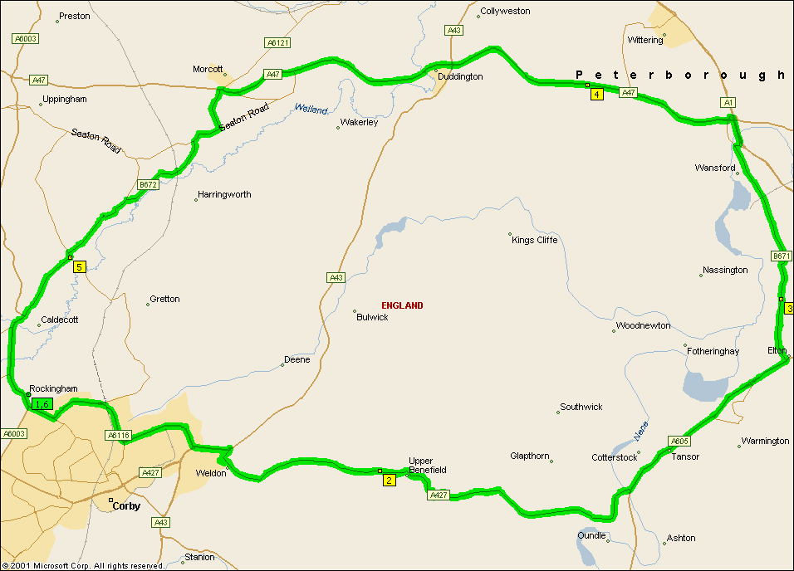
Summary: 40.2 miles (1 hour, 13 minutes)
Time | Mile | Instruction | For | Toward
09:00 | 0.0 | Depart Rockingham on Local road(s) (West) | 153 yds
09:00 | 0.1 | Turn LEFT (South) onto A6003 | 0.1 mi
09:00 | 0.2 | At roundabout, take the FIRST exit | 32 yds
09:01 | 0.2 | Exit roundabout onto A6116 [Rockingham Road] | 0.5 mi
09:02 | 0.8 | At roundabout, take the FIRST exit | 10 yds
09:02 | 0.8 | Exit roundabout onto A6116 [Gretton Brook Road] | 174 yds
09:02 | 0.9 | At roundabout, take the SECOND exit | 43 yds
09:02 | 0.9 | Exit roundabout onto A6116 [Gretton Brook Road] | 1.7 mi
09:05 | 2.5 | At roundabout, take the FIRST exit | 10 yds
09:05 | 2.6 | Exit roundabout onto A6116 [Steel Road] | 1.1 mi
09:08 | 3.7 | At roundabout, take the SECOND exit | 87 yds
09:08 | 3.7 | Exit roundabout onto A6116 [Steel Road] | 0.4 mi
09:08 | 4.1 | At roundabout, take the FIRST exit | 10 yds
09:08 | 4.1 | Exit roundabout onto A43 | 0.6 mi
09:10 | 4.8 | At roundabout, take the SECOND exit | 76 yds
09:10 | 4.8 | Exit roundabout onto A427 [Stamford Road] | 3.4 mi
09:16 | 8.2 | At A427, stay on A427 (East) | 5.5 mi
09:27 | 13.7 | At roundabout, take the FIRST exit | 10 yds
09:27 | 13.7 | Exit roundabout onto A605 | 2.0 mi
09:30 | 15.8 | At roundabout, take the SECOND exit | 21 yds
09:30 | 15.8 | Exit roundabout onto A605 | 1.7 mi
09:33 | 17.4 | Turn LEFT (North) onto B671 | 1.2 mi
09:35 | 18.6 | At B671, stay on B671 [Wansford Road] (North) | 3.0 mi
09:41 | 21.6 | Turn RIGHT (East) onto Local road(s) | 0.2 mi
09:42 | 21.8 | Continue (North) on A1 [Great North Road] | 0.4 mi
09:43 | 22.3 | Continue (North) on Ramp | 131 yds | A47 / Peterborough / Leicester
09:43 | 22.3 | Bear LEFT (South-West) onto A6118 [Old North Road] | 120 yds
09:43 | 22.4 | Turn RIGHT (West) onto A47 | 2.7 mi
09:47 | 25.1 | At A47, stay on A47 (West) | 2.7 mi
09:51 | 27.8 | At roundabout, take the SECOND exit | 76 yds
09:51 | 27.9 | Exit roundabout onto A47 | 4.5 mi
09:59 | 32.4 | Turn LEFT (South) onto B672 | 4.7 mi
10:07 | 37.0 | At B672, stay on B672 [Lyddington Road] (West) | 1.4 mi
10:10 | 38.4 | Bear LEFT (South) onto A6003 [Main Street] | 1.7 mi
10:13 | 40.1 | Turn LEFT (East) onto Local road(s) | 153 yds
10:13 | 40.2 | Arrive Rockingham

SUMMARY
Driving distance: 40.2 miles
Trip duration: 1 hour, 13 minutes
Driving time: 1 hour, 13 minutes
Cost: £5.10

